

**Azara Report Generation Tool: Use and Updates**

**for**

**Mr. Eric Rogers, Director of Integrated Care**

**12 February 2015**

**USE AND UPDATES**

**Report Generator Control Panel:**

**Normal Use:**

* Upon launching the MS Access file, the control panel will open.
* The user interface has a built-in set of instructions to guilds the user through the process:

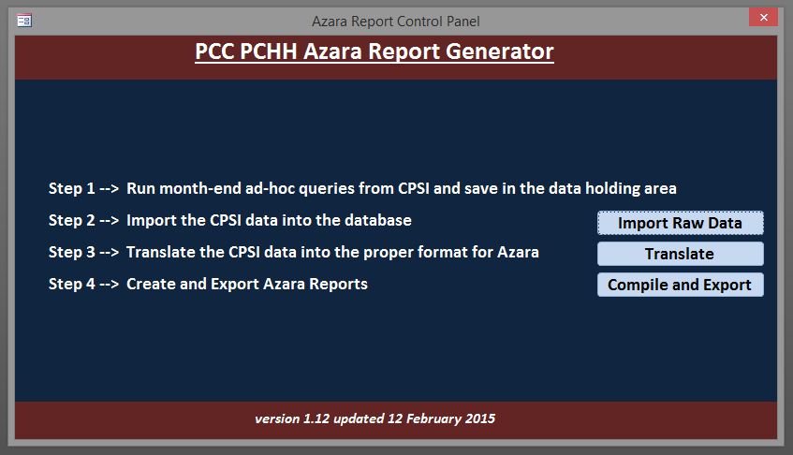

* **Step 1:**
  + Extracting current data from CPSI is a process outside the scope of the Report Generation Tool, and must be executed ***prior*** to running the Report Generator (for detailed discussion on this process, please refer to the guide on Ad-Hoc reporting). As long as there are spreadsheets in “1 - Holding Area for Raw Data”, the generator will function. However, will produce reports for old data.
* **Step 2:**
  + Step 2 imports the 7 CPSI Raw Data spreadsheets from the Holding Area folder into the background of the Report Generator. During this process, the Report Generator ensures that all of the raw data is on the proper computer data “type” (i.e.: numbers are numbers, text is text, dates are dates). As the process nears completion, the Report Generator creates new database tables to house the imported information.
* **Step 3:**
  + The translation step represents the processes whereby the CPSI-formatted data is made to conform to the data standards required by Azara in the final reports. During this step, multiple functions are executed. These processes include (but are not exclusive to: mapping data through reference several reference tables to translate CPSI codes into Azara English, populate fields with required information that are not directly available in a CPSI Ad-Hoc extract (such as mapping the Physicians name to his or her National Provider Number) and concatenating data and time fields to conform to the required Azara standard.
* **Step 4:**
  + Compiling and Exporting the reports is the final step of the process. Properly formatted data is extracted from the database and assembled into the report formats required for the Azara submission. Once compiled, these reports are extracted to the “Extracted Reports” folder as Excel spreadsheets. These spreadsheets display all of the properly formatted data that may be run through the report validation tool, and finally translated into the .xml format required for final transmission to Azara.

**Updates:**

* Barring significant changes to information availability or reporting requirements, the Report Generator will remain stable without updates throughout the duration of calendar-year 2015.
* Several of the key reference tables the Report Generator requires are provided as easy-to-read Excel spreadsheets in the “Background Information” folder. When significant changes to the content of these tables occurs (such as a new provider is caring for patients in the Integrated Care program, or the calendar year ends), a simple update and re-import into the Report Generator may be required.
* If significant changes in the availability of patient data (such as when the EMR is fielded), or reporting requirements imposed by Azara occur, a holistic review of the Report Generator is in order.